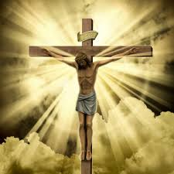

The only perfect sacrifice is the one that Christ offered on the cross as a total offering to the Father’s love and for our salvation.

Giving helps us to identify with the complete sacrifice of Jesus which is remembered in the liturgy of Holy Week, especially the Easter Triduum (Holy Thursday, Good Friday and Holy Saturday – Easter Sunday).

**OUR BIG QUESTION**

Why do we need to make sacrifices?

**KEY VOCABULARY**

temptation betrayal self-sacrifice Gethsemane

crucifixion Easter vigil Resurrection

Lent is the season when Christians try to focus on giving.

**REFLECTION**

Lord, when I am hungry give me someone to feed;

When I am thirsty give water for their thirst.

When a burden weighs upon me lay upon my shoulders the burden of my fellows.

Lord, when I stand greatly in need of tenderness, give me someone who yearns for love. May your will be my bread;

Your grace my strength; Your love my resting place.

**SACRIFICE**

Year 5 Topic 6

**SCRIPTURE**

Matthew 26: 14-16, 25, 38-48, 47-50

Matthew 28: 1-10

Mark 14: 10-11, 32-36, 43-46

Mark 15: 1-15, 21-41

Luke 4: 1-12

Luke 22:39-46

Luke 23: 26-43

John13: 34-35, John 20: 1-10