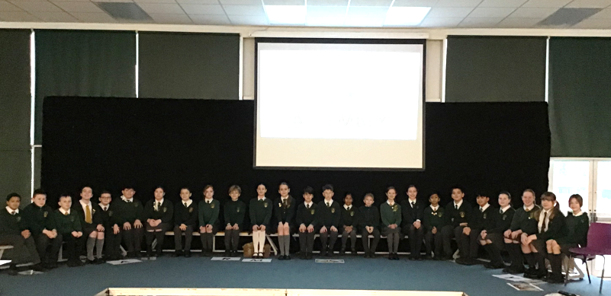

*6ST’s Assembly- Inspirational Women*

On Thursday, 6ST had their class assembly all about inspirational women who have helped change or improve our world. They reminded us of the importance of Miriam in the book of Exodus. Miriam’s courage when asked to watch over baby Moses in the river Nile is a pivotal role in the story. Without her bravery to wait by the river and watch over him, Moses would almost certainly have been discovered by the wrong person. They also reminded us that Mary, the mother of Jesus, is an inspiration to us and an example to Catholics of how to live a faithful life. 6ST finished by telling us all about the inspirational women in our own lives who have some of the same special qualities.

A fantastic assembly 6ST!