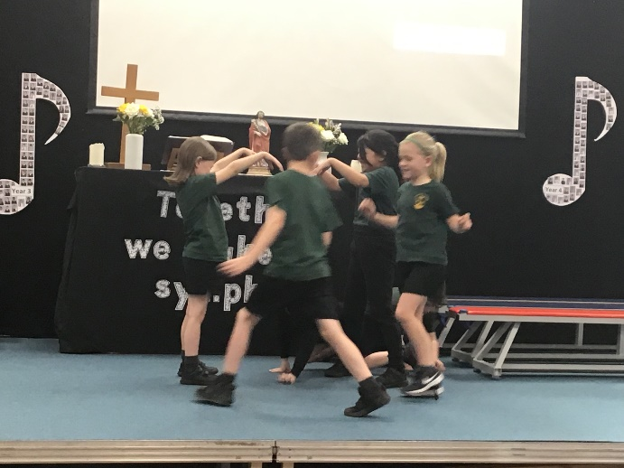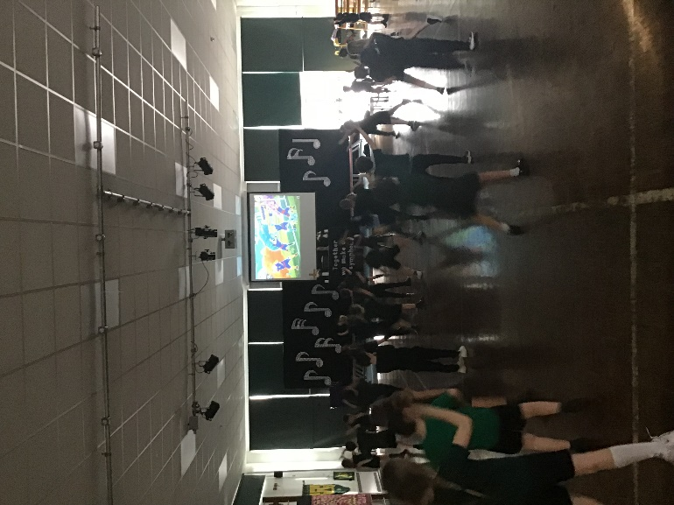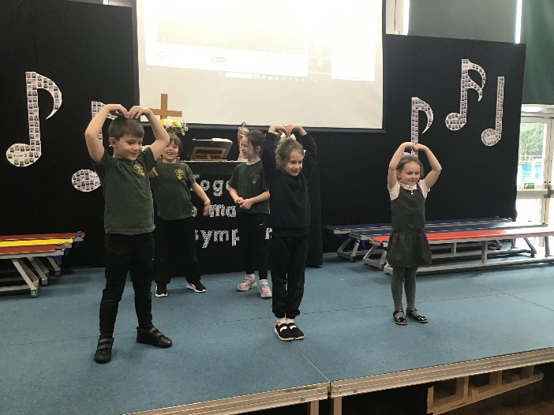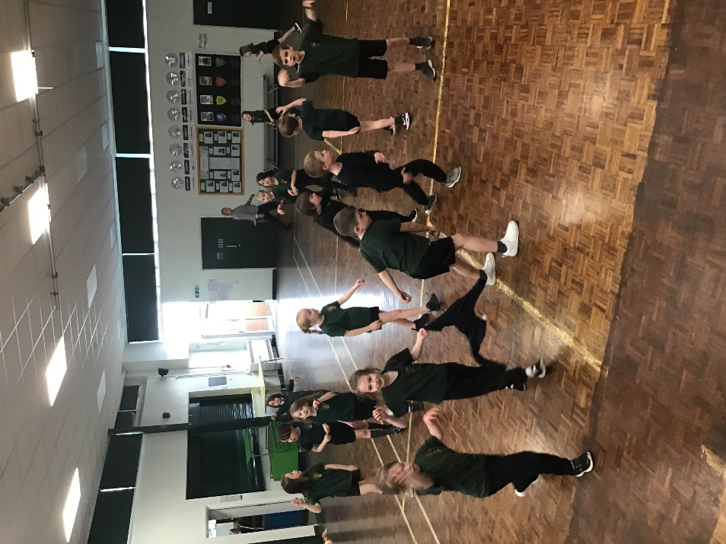PE afternoon – Dance

Our PE afternoon was themed around the jungle, focusing on dance and movement. We started with a warm-up where I called out different animals, and the children moved around while mimicking their actions. After warming up, the class split into groups of five to create their own jungle-themed dances, using their bodies to form different elements of a jungle scene. To wrap up the session, everyone joined in for a fun Just Dance routine, following along with the teachers. The afternoon was energetic, creative, and a great way to get active through dance!